NAME OF THE PAPER FOR THE WR20 CONFERENCE
Title: Concise and informative. Titles are often used in information-retrieval systems. Avoid abbreviations and formulae where possible.
(Times New Roman, font size of 13 points, bold, centered)

Name SURNAME¹, Name SURNAME²
Author’s name (Times New Roman, font size of 12 points, bold, centred; (Surname must be in capital))

¹Affiliation of Author 1, Address of the organization, author’s e-mail
²Affiliation of Author 2, Address of the organization, author’s e-mail

Author’s address, e-mail (Times New Roman, font size of 10 points, centered)

Abstract
A concise and factual abstract is required. The abstract should state briefly the purpose of the research, the principal results and major conclusions. An abstract is often presented separate from the article, so it must be able to stand alone. References should therefore be avoided, but if essential, they must be cited in full, without reference to the reference list. Non-standard or uncommon abbreviations should be avoided, but if essential they must be defined at their first mention in the abstract itself.
(Times New Roman, font size of 9 points, max. 15 lines)

Keywords: Immediately after the abstract, provide a maximum of 6 keywords, avoiding general and plural terms and multiple concepts (avoid, for example, 'and', 'of'). Be sparing with abbreviations: only abbreviations firmly established in the field may be eligible.
(Times New Roman, font size of 9 points, Italics, 3-6 keywords)

Introduction
State the objectives of the work and provide an adequate background, avoiding a detailed literature survey or a summary of the results.
Paper text (Times New Roman, font size of 10 points), the whole article should not exceed 4 pages (!) including figures and supplements.

Figures and Tables should be typed in the text. Reference to Figures and Table should be included in the Text. Graphs and schemes enclose only in format TIF, JPG, PNG, GIF.

Page format – A4. Page margins – right: 2.5 cm, left: 2.0 cm, top margin: 3.0 cm, bottom margin: 2.5 cm, line spacing: single.

Materials and methods/Area description
Provide sufficient detail to allow the work to be reproduced. Methods already published should be indicated by a reference: only relevant modifications should be described.

(Times New Roman, font size of 10 points)

Results and discussion
This should explore the significance of the results of the work, not repeat them.

(Times New Roman, font size of 10 points)

Table 1. Results of bacterial leaching
(Times New Roman, font size of 9 points, left align, only use horizontal lines, legend below the Table)
Leaching time  (weeks) | Metal concentration (%) |  |  |  | Recovery of metal (%) |  |  |  | Fe ²⁺  (mg.l⁻¹) | Amount of bacteria in 1 ml
 | Zn | Pb | Cd | Cu | Zn | Pb | Cd | Cu
1
2

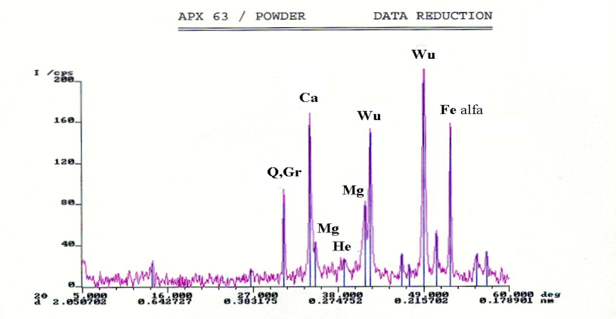
Figure 1. X-ray - diffraction, Pribram sample
(Times New Roman, font size of 9 points, centred)

Conclusions
A short conclusion section is to be presented.

(Times New Roman, font size of 10 points)

Acknowledgements
Place acknowledgements, including information on grants received.

(Times New Roman, font size of 10 points)

References
Bibliographic references acording to ISO 690 and ISO 690-2.

(Times New Roman, font size of 9 points)

Citations in the text: Please ensure that every reference cited in the text is also present in the reference list (and vice versa). Any references cited in the abstract must be given in full. Unpublished results and personal communications should not be in the reference list, but may be mentioned in the text. Citation of a reference as 'in press' implies that the item has been accepted for publication.
Citing and listing of web references: As a minimum, the full URL should be given. Any further information, if known (author names, dates, reference to a source publication, etc.), should also be given. Web references can be listed separately (e.g., after the reference list) under a different heading if desired, or can be included in the reference list.
Text: All citations in the text should refer to:
- Single author: the author's name (without initials, unless there is ambiguity) and the year of publication;
- Two authors: both authors' names and the year of publication;
- Three or more authors: first author's name followed by 'et al.' and the year of publication. Citations may be made directly (or parenthetically). Groups of references should be listed first alphabetically, then chronologically.

Examples: "as demonstrated (Allan, 1996a, 1996b, 1999; Allan and Jones, 1995). Kramer et al. (2000) have recently shown ...."
List: References should be arranged first alphabetically and then further sorted chronologically if necessary. More than one reference from the same author(s) in the same year must be identified by the letters "a", "b", "c", etc., placed after the year of publication.
Examples:
Reference to a journal publication:
FEČKO, Peter et al. Bacterial desulphurization of coal. Górnictwo i geoinžynieria, Zesyt 3/1, r. 30, 2006, p. 47-66, ISSN 1732-6702.
FEČKO, Peter et al. Bacterial desulphurization of coal from mine ČSA Most. In Journal of Mining and Metallurgy, 42B (1), 2006, p. 13-24, ISSN 1450-5339.

Reference to a proceedings publication:
REISSIG, Wolfgang. Elements of distributed algorithms : modeling and analysis with Petri nets.Berlin : Springer, 1998. xi, 302 s. ISBN 3-540-62752-9.
HERZOG, Ulrich. Formal methods for performance evaluation. In BRINKSMA, Ed; HERMANNS, ČABLÍK, Vladimír; FEČKO, Peter. Možnost aplikace bakterií Thiobacillus ferrooxidans na popílek z elektrárny Vřesová. In FEČKO, Peter (ed.). Recyklace odpadů IV : 27. 10. 2000, VŠB-TU Ostrava. Ostrava : VŠB-Technická univerzita Ostrava, 2000, s. 247-250. ISBN 80-7078-822-4.

Reference to a book publication:
FEČKO, Peter et al. Environmental Biotechnology. 1st edition. Ostrava : Publishing services department VŠB-TU Ostrava, 2006, p. 182, ISBN 80-248-1090-5.

Reference to standard specifications:
Test method G5-94 (1999). Standard reference test method for making potentiostatic and potentiodynamic anodic polarization measurements. West Conshohocken : American Society for Testing and Materials, 1999. 12 s.
DIN 2395-2. Geschweißte Präzisionsstahlrohre mit rechteckigem und quadratischem Querschnitt : technische Lieferbedingungen für allgemeine Verwendung. Berlin : DIN Deutsche Institut für Normung, 1994. 4 s.
ČSN EN ISO 9004. Systémy managementu jakosti : směrnice pro zlepšování výkonnosti. Praha : Český normalizační institut, 2001. 93 s.

Reference to electronic journal publication:
JOSEPH, Heather. An economic model for Web enhancements to a print journal. Journal of Electronic Publishing [online]. 2002, vol. 7, no. 3, April [cit. 2008-02-14]. Dostupný z WWW: <http://hdl.handle.net/2027/spo.3336451.0007.302>. ISSN 1080-2711.

Reference to web site:
TKAČÍKOVÁ, Daniela. Jak pracovat s informacemi [online]. Ostrava : VŠB-TU Ostrava, Ústřední knihovna, aktualizováno 6. 1. 2009 [cit. 2009-01-06]. Dostupný z WWW: <http://knihovna.vsb.cz/kurzy/>.
RefWorks [online]. c2008 [cit. 2008-05-22]. Dostupný z WWW: <http://www.refworks.com/>.
Slovníky | Atlas.cz : cizojazyčné slovníky portálu Atlas.cz [online]. [cit. 2008-05-22]. Dostupný z WWW: <http://slovniky.atlas.cz/>.

